Civil war in Georgia

UNSC Resolution: | 1124
Date of adoption: | 31-July-1997
Operative paragraph: | 6
Demand number: | 1124.0611

David Siroky

Wording of demand

engage constructively (in particular the Abkhaz side) at the resumed meeting referenced in addendum to the report of the SG (S/1997/558)

List of addressees of the demand

Government of Georgia, Abkhazia

Short-term compliance

Description of the addressee(s)’ conduct

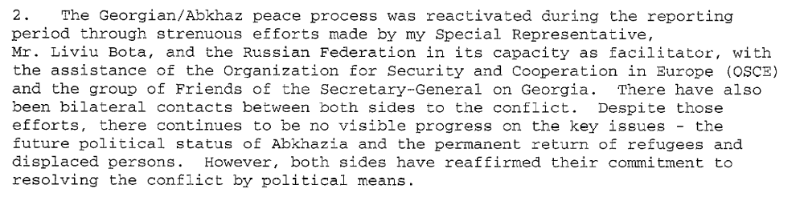
s/1997/827

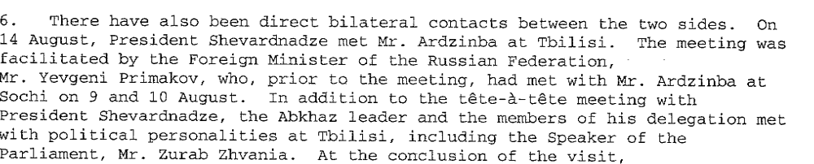

s/1997/827

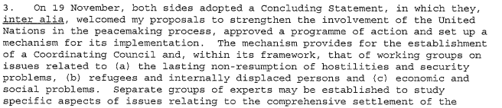

s/1998/51

Assessment

Short-term compliance
No or marginal compliance (1) | Medium low compliance (2) | Medium high compliance (3) | Full or almost full compliance (4)

Considerations underlying the assessment

Medium-term compliance

Description of the addressee(s)’ conduct

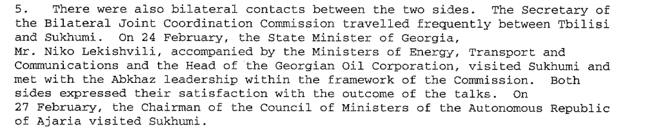

s/1998/375

Assessment

Medium-term compliance
No or marginal compliance (1) | Medium low compliance (2) | Medium high compliance (3) | Full or almost full compliance (4)

Considerations underlying the assessment

Depth of demand

Assessment

Level of depth of demand
Low depth of demand (1) | Medium depth of demand (2) | High depth of demand (3)

Considerations underlying the assessment

Level of confidence about coding decisions
Level of confidence about coding decision
Extremely high | High | Moderate

Comments to IPI (if any)

Civil war in Georgia

UNSC Resolution: | 1124
Date of adoption: | 31-July-1997
Operative paragraph: | 7
Demand number: | 1124.0711

David Siroky

Wording of demand

achieve substantive progress without further delay towards a comprehensive political settlement (in particular the Abkhaz side) and cooperate with the efforts undertaken by the Secretary-General with the assistance of the Russian Federation as facilitator

List of addressees of the demand

Government of Georgia, Abkhazia

Short-term compliance

Description of the addressee(s)’ conduct

s/1997/827

s/1997/827

s/1998/51

Assessment

Short-term compliance
No or marginal compliance (1) | Medium low compliance (2) | Medium high compliance (3) | Full or almost full compliance (4)

Considerations underlying the assessment

Medium-term compliance

Description of the addressee(s)’ conduct

s/1998/375

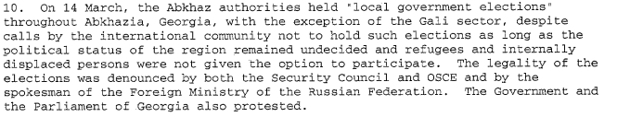

s/1998/375

Assessment

Medium-term compliance
No or marginal compliance (1) | Medium low compliance (2) | Medium high compliance (3) | Full or almost full compliance (4)

Considerations underlying the assessment

Depth of demand

Assessment

Level of depth of demand
Low depth of demand (1) | Medium depth of demand (2) | High depth of demand (3)

Considerations underlying the assessment

Level of confidence about coding decisions

Level of confidence about coding decision
Extremely high | High | Moderate

Comments to IPI (if any)

Civil war in Georgia

UNSC Resolution: | 1124
Date of adoption: | 31 July 1997
Operative paragraph: | 8
Demand number: | 1124.0811

David Siroky

Wording of demand
intensify the search for a peaceful solution by further expanding contacts and pursue the discussions on the implementation of the above-mentioned decisions of 28 March 1997 adopted by the Council of Heads of State of the CIS [to expand the mandate of the CIS
peacekeeping force in the conflict zone in Abkhazia, Georgia]

List of addressees of the demand
Government of Georgia, Abkhazia

Short-term compliance

Description of the addressee(s)’ conduct

The Georgian/Abkhaz peace process was reactivated during the reporting period…There have also been bilateral contacts between both sides to the conflict. (S-G’s Report, October 1997)

Mr. Bota had intended, after the consultations with the two sides, to resume the adjourned meeting [of 23 and 25 July] on 13 October at Geneva, but was informed on 8 October by the Abkhaz leader that the Abkhaz side needed more time for preparation of substantive issues…It had now been agreed that the meeting should be resumed at Geneva on 17 November. (S-G’s Report, October 1997)

On 1 August, President Boris Yeltsin of the Russian Federation invited leaders from both sides to join him for a meeting in Moscow aimed at making headway in the peace process…Though both President Shevardnadze and Mr. Ardzinba welcomed the initiative, they preferred to conduct further preparatory work before meeting in Moscow. (S-G’s Report, October 1997)

Georgian/Abkhaz negotiations took place at Sukhumi on 9 and 10 September under the chairmanship of the First Deputy Foreign Minister of the Russian Federation…In a joint communiqué adopted at the end of the negotiations, the parties, inter alia, reaffirmed their determination to strive towards a prompt resolution of existing problems and the signing of the draft Protocol in Moscow in the near future. (S-G’s Report, October 1997)

There have also been direct bilateral contacts between the two sides. On 15 August, President Shevardnadze met Mr. Arbzinba at Tbilisi. (S-G’s Report, October 1997)

The CIS force continues to operate static checkpoints throughout the security zone and its patrolling remains limited because of the persistent mine threat. As the Securty Council was informed on 14 October, two of the force’s officers were severely wounded recently when attempting to defuse a body-trapped device. (S-G’s Report, October 1997)

The mandate of the CIS peacekeeping force, which expired on 31 July has been under consideration by political and military officials of the Russian Federation and the Government of Georgia. Following discussions at the Summit of the Council of Heads of State of CIS, which began on 22 October, the mandate was extended until 31 January 1998. (S-G’s Report, October 1997)

Assessment

Short-term compliance
No or marginal compliance (1) | Medium low compliance (2) | Medium high compliance (3) | Full or almost full compliance (4)

Considerations underlying the assessment

Medium-term compliance

Description of the addressee(s)’ conduct

The sides continued extensive negotiation efforts on a set of two documents, in preparation for a meeting between the President of Georgia and the Abkhaz leader. (S-G’s Report, July 1998)

While the above-mentioned proceeded, my Special Representative was actively engaged in direct consultations with President Shevardnadze, Mr. Adrzinba and other prominent political figures. Each leader continued to express willingness to meet with the other to address current problems and explore avenues for the settlement of the conflict (S-G’s Report, July 1998)

In addition, on 16 June, the members of the group of Friends of the Secretary-General met with President Shevardnadze in Tbilisi and, on 17 June, with Mr. Ardzinba in Sukhum, at his invitation. In each case, they made collective demarches appealing to both sides to resume discussions within the institutional framework agreed upon during the high-level meeting held at Geneva in November 1997 (Secretary-General’s Report, July 1998)

The weekly quadripartite meetings chaired by the Commander of the CIS peacekeeping force have continued during the period under review. Neither the Georgian administration nor police were present at any of the meetings, except on 15 April when the Deputy Mayor of Zugdidi attended. (Secretary-General’s Report, May 1998)

The Abkhaz leadership expressed its support for the extension of the mandate of the CIS peacekeeping force. (Secretary-General’s Report, May 1998)

Following the Athens meeting of the Georgian and Abkhaz side on confidence-building measures, held from 16 to 18 October 1998, the largest and most representative meetng between the parties since the end of the war of 1993, my Special Representative continued to meet frequently with the two sides and others concerned. (S-G’s Report) January 1999

While the above-mentioned efforts were under way, my Special Representative was actively engaged in consultations with the President of Georgia, the Abkhaz leader, and other prominent political figures in Georgia. Each leader continued to express willingness to meet with the other to talk about current problems and to explore possible steps to facilitate a settlement of the conflict. (S-G’s Report, January, 1999)

During the reporting period, bilateral contacts between the two sides included visits to Tbilisi, on 29 October and 22 November 1998, by the personal representative of Mr. Ardzinba to the peace process, Anri Jergenia, accompanied by the Abkhaz de fact Deputy Defence Minster, Major General Givi Agrba, for talks with the Georgian State Minister, Vazha Lordkipanidze. (S-G’s Report, January 1999)

The weekly [CIS] quadripartite meetings were subject to a prolonged boycott of almost two months by the Abkhaz side as a protest against the abduction of Abkhaz militiamen and the failure of the troops of the Georgian Interior Ministry to withdraw from the Khurcha pocket. (S-G’s Report, January 1999)

The expiration of the mandate of the CIS peacekeeping force on 30 June 1998 has not affected its presence. The force continues to operate from static checkpoints, located mostly along the ceasefire line and to perform very limited mobile patrolling. (S-G’s Report, January 1999)

Assessment

Medium-term compliance
No or marginal compliance (1) | Medium low compliance (2) | Medium high compliance (3) | Full or almost full compliance (4)

Considerations underlying the assessment

Depth of demand

Assessment

Level of depth of demand
Low depth of demand (1) | Medium depth of demand (2) | High depth of demand (3)

Considerations underlying the assessment

Level of confidence about coding decisions

Level of confidence about coding decision
Extremely high | High | Moderate

Comments to IPI (if any)

Civil war in Georgia

UNSC Resolution: | 1124
Date of adoption: | 31-July-1997
Operative paragraph: | 12
Demand number: | 1124.1211

David Siroky

Wording of demand

accelerate significantly the process of voluntary return of refugees and displaced persons without delay or preconditions, in particular by accepting a timetable on the basis of that proposed by the Office of the UN High Commissioner for Refugees and guarantee the safety of spontaneous returnees already in the area and regularize their status in cooperation with UNHCR and in accordance with the Quadripartite Agreement, in particular in the Gali Region

List of addressees of the demand

Abkhazia

Short-term compliance

Description of the addressee(s)’ conduct

s/1998/51

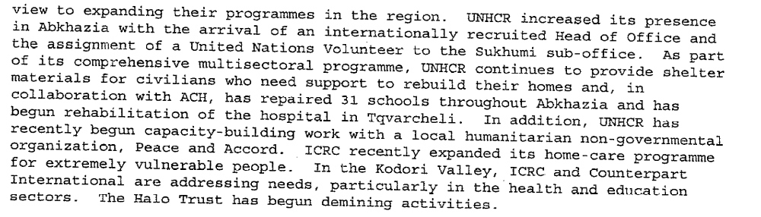
s/1998/51

Assessment

Short-term compliance
No or marginal compliance (1) | Medium low compliance (2) | Medium high compliance (3) | Full or almost full compliance (4)

Considerations underlying the assessment

Medium-term compliance

Description of the addressee(s)’ conduct

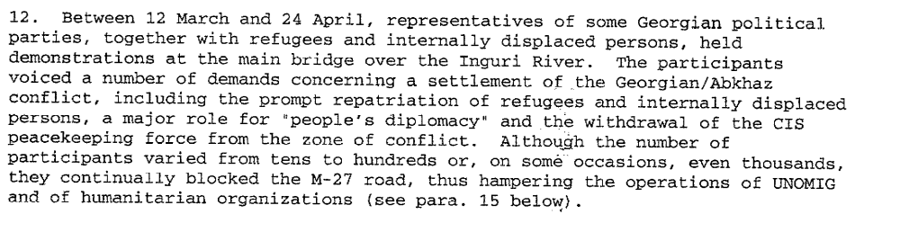s/1998/375

s/1998/375

s/1998/375

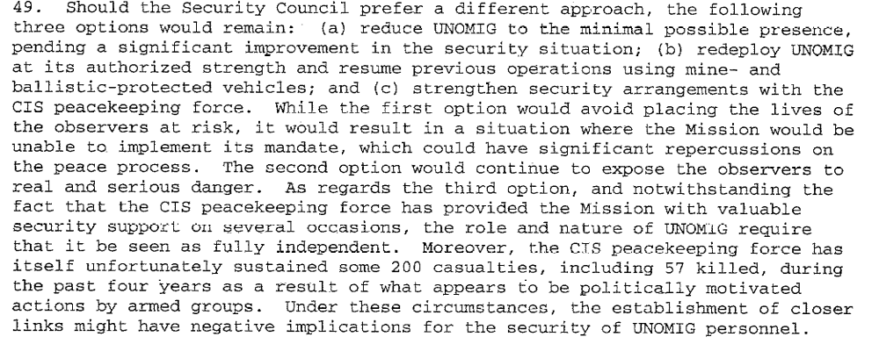

s/1998/375

Assessment

Medium-term compliance
No or marginal compliance (1) | Medium low compliance (2) | Medium high compliance (3) | Full or almost full compliance (4)

Considerations underlying the assessment

Depth of demand

Assessment

Level of depth of demand
Low depth of demand (1) | Medium depth of demand (2) | High depth of demand (3)

Considerations underlying the assessment

Level of confidence about coding decisions

Level of confidence about coding decision
Extremely high | High | Moderate

Comments to IPI (if any)

Civil war in Georgia

UNSC Resolution: | 1124
Date of adoption: | 31-July-1997
Operative paragraph: | 13
Demand number: | 1124.1311

David Siroky

Wording of demand

ensure the full implementation of the Moscow Agreement [S/1994/583 Annex 1]

List of addressees of the demand

Government of Georgia, Abkhazia

Short-term compliance

Description of the addressee(s)’ conduct

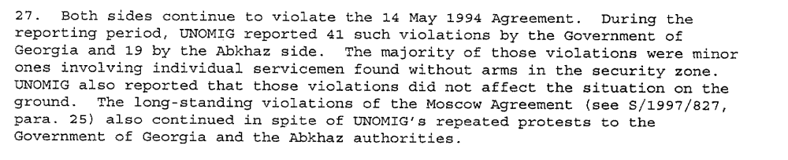
s/1998/51

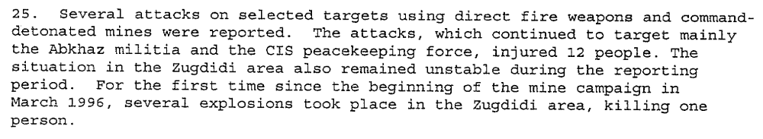
s/1998/51

Assessment

Short-term compliance
No or marginal compliance (1) | Medium low compliance (2) | Medium high compliance (3) | Full or almost full compliance (4)

Considerations underlying the assessment

Medium-term compliance

Description of the addressee(s)’ conduct

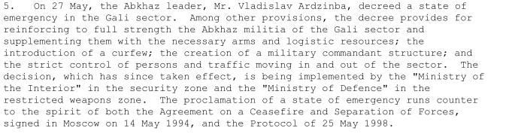
s/1998/497

Assessment

Medium-term compliance
No or marginal compliance (1) | Medium low compliance (2) | Medium high compliance (3) | Full or almost full compliance (4)

Considerations underlying the assessment

Depth of demand

Assessment

Level of depth of demand
Low depth of demand (1) | Medium depth of demand (2) | High depth of demand (3)

Considerations underlying the assessment

Level of confidence about coding decisions

Level of confidence about coding decision
Extremely high | High | Moderate

Comments to IPI (if any)

Civil war in Georgia

UNSC Resolution: | 1124
Date of adoption: | 31 July 1197
Operative paragraph: | 14
Demand number: | 1124.1411

David Siroky

Wording of demand
take all measures in their power to prevent mine laying and cooperate fully with UNOMIG and the CIS peace-keeping force in order to honour their commitments to ensure the safety and the freedom of movement of all personnel of the UN, the CIS peace-keeping force and international humanitarian organizations

List of addressees of the demand

Government of Georgia, Abkhazia

Short-term compliance

Description of the addressee(s)’ conduct

As Council members have seen, the mine threat and armed and criminal activities have been threatening the lives of innocent civilians and have affected the operations of aid agencies, the CIS peacekeeping force and UNOMIG…I again call on both sides to do all they can to improve the security situation in the area and to put an end to such activities, which are seriously affecting the lives of the population (S-G’s Report, October 1997)

During the period covered by this report, armed groups operating from south of the Inguri River added another dimension to their tactics as small groups now infiltrate deep into Abkhaz territory. In addition, on two occasions and for the first time since the inception of the Mission, both the CIS peacekeeping for and UNOMIG were the victims of hostage taking incidents in the Zugdidi sector. On 16 August, three members of the CIS peacekeeping force were taken hostage in the security zone [Georgian security forces did aid in the release of hostages]. (S-G’s Report, October 1997)

The CIS force continues to operate static checkpoints throughout the security zone and its patrolling remains limited because of the persistent mine threat. As the Securty Council was informed on 14 October, two of the force’s officers were severely wounded recently when attempting to defuse a body-trapped device. (S-G’s Report, October 1997)

The mandate of the CIS peacekeeping force, which expired on 31 July has been under consideration by political and military officials of the Russian Federation and the Government of Georgia. Following discussions at the Summit of the Council of Heads of State of CIS, which began on 22 October, the mandate was extended until 31 January 1998. (S-G’s Report, October 1997)

Assessment

Short-term compliance
No or marginal compliance (1) | Medium low compliance (2) | Medium high compliance (3) | Full or almost full compliance (4)

Considerations underlying the assessment

Medium-term compliance

Description of the addressee(s)’ conduct

The weekly quadripartite meetings chaired by the Commander of the CIS peacekeeping force have continued during the period under review. Neither the Georgian administration nor police were present at any of the meetings, except on 15 April when the Deputy Mayor of Zugdidi attended. (Secretary-General’s Report, May 1998)

The Abkhaz leadership expressed its support for the extension of the mandate of the CIS peacekeeping force. (Secretary-General’s Report, May 1998)

Mine-layng and other armed activities by certain groups, who appear to be politically motivated and to target mostly the Abkhaz authorities and the CIS peacekeeping force, also continued during the reporting period, killing 2 Abkhaz officers and 4 civilians and injuring 10 soldiers from the CIS force, 10 Abkhaz officers and 4 civilians. (S-G’s Report, May 1998)

The weekly [CIS] quadripartite meetings were subject to a prolonged boycott of almost two months by the Abkhaz side as a protest against the abduction of Abkhaz militiamen and the failure of the troops of the Georgian Interior Ministry to withdraw from the Khurcha pocket. (S-G’s Report, January 1999)

Assessment

Medium-term compliance
No or marginal compliance (1) | Medium low compliance (2) | Medium high compliance (3) | Full or almost full compliance (4)

Considerations underlying the assessment

Depth of demand

Assessment

Level of depth of demand
Low depth of demand (1) | Medium depth of demand (2) | High depth of demand (3)

Considerations underlying the assessment

Level of confidence about coding decisions

Level of confidence about coding decision
Extremely high | High | Moderate

Comments to IPI (if any)

to IPI (if any)

